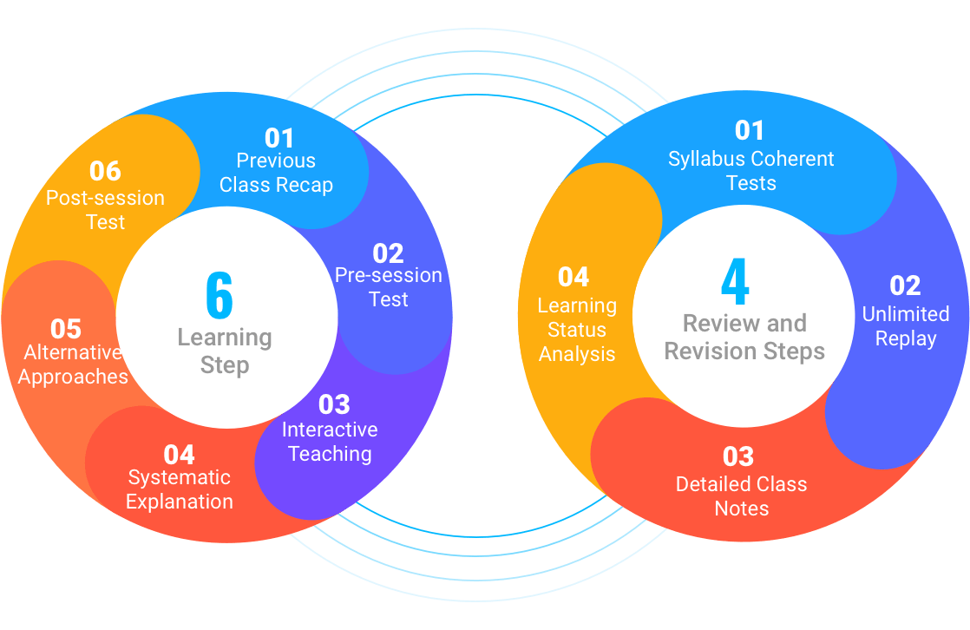

7 STEP LEARNING STRATEGY

1. Previous Session Revision
2. 45-50 Min. Interactive Teaching
3. Question Hour - Alternative Approach & Unlimited Iterations
4. Detailed Class Notes
5. Zero Hour - Coherent Doubt Solving Sessions
6. Interaction with Student
7. Learning Analysis & Regular Reports

45-50 min class – 1. Question Hour 2. Zero Hour

Recap of previous sessions

Interatction with students

Learning analysis & regular reports

LIVE CLASSROOM

1. Personlized audio/video interaction tool
2. One-to-one Interaction with the teachers
3. Maximum 7 students per class
4. Interactive features to keep students focussed

EXPERT EDUCATORS

1. Minimum 5 years of experience holding educators
2. Taught students for different platforms like CBSE, IIT, IB, NEET, Olympiad
3. Detailed Sessions along with our Zero Hour
4. <>

READY TO GO DATA

1. Access Unlimited content 100% free
2. Detailed q/a along with the test papers for each chapter
3. On Demand CBSE Notes
4. Revision Sample Papers for every subject/class